**High Level Design**

**Brendan College, Alejandro Fernandez, Charles Karlson, Samantha Maddox (Group 6)**

**Project 1: Group Matching App**

**COP 4331, Fall 2021**

**Contents of this Document**

High-Level Architecture

Design Issues

**High-level Architecture**

*Major Component Diagram*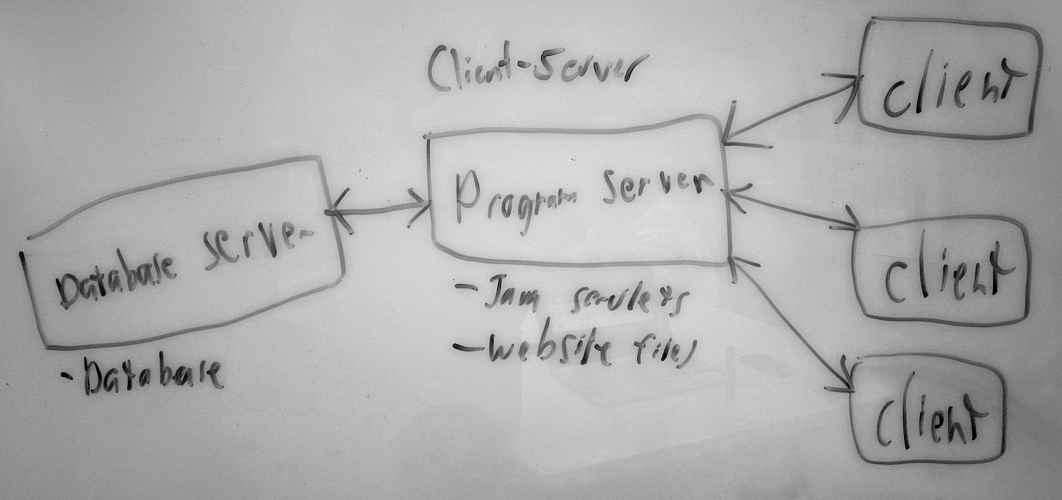

*System Interface Diagram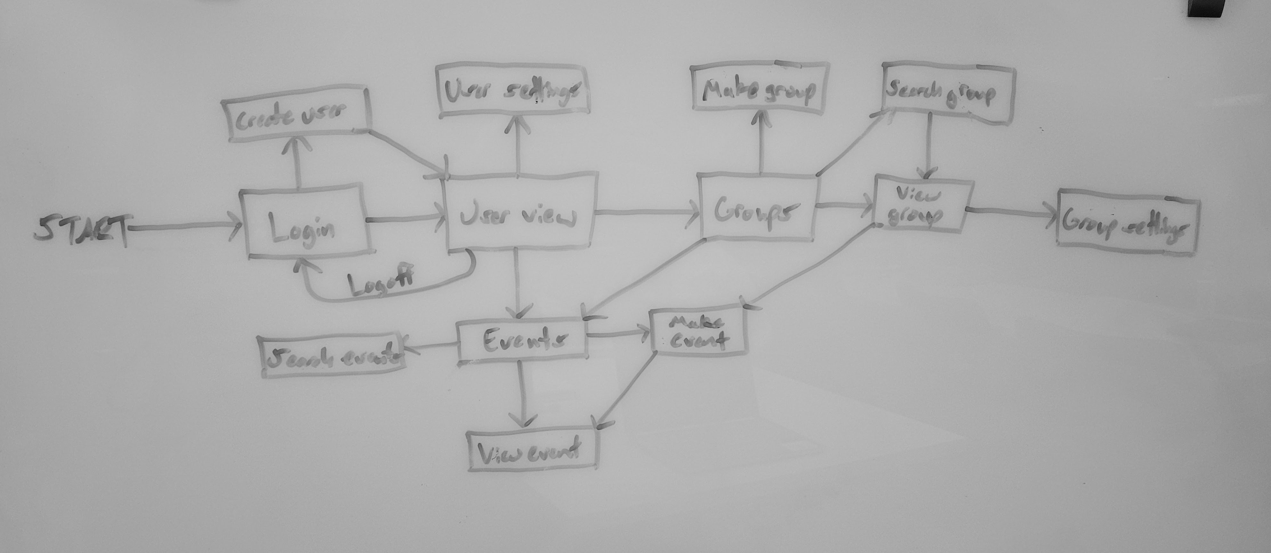*

**Design Issues**

*Major Design Issues*

Reliability:

* Will be a concern due to time and testing constraints

Reusability:

* Continuous instance of myMeet unless reset or shut down by developers
* Service can easily be replicated and rebranded if source code present

Maintainability:

* Under constant watch by developers
* Bug reports should be

Testability:

* Developers will evaluate use cases and will perform tests based on those use cases
* Will ensure performance is consistent

Performance:

* Resource-light for users
* Speed not imperative for operations performed in the application
* Lightweight database query

Portability:

* Users
  + Extremely portable
  + Reliant only on an internet connection and browser
  + Resource-light
* Developers
  + Unportable
  + One instance of myMeet at a time
  + One database
  + Setup is involved (but not necessarily intensive)

Security:

* Database security
  + Database restrictions encoded in Java program
  + Duplication of primary keys disallowed
* Passwords and sensitive information hashed
  + Password reset functionality
* Focus on user privacy
* Eventually will become open source

Safety:

* Safeguards against malicious behavior
  + Kick users
  + Block users
  + Minimum age
* User privacy

*Architecture Rationale*

* Developer experience with Java, Python, and MySQL
* Developers wish to learn new skills and further their experience using industry practices
* Requirements and recommendations set by professor and teaching assistants led to the project evolving into a more complex organism
  + Originally programmed solely in Java
  + Latest evolution incorporates Java, JavaScript, MySQL, and Python
* Minimize complication
* Up-to-date languages

*Technical Difficulties and Risks*

* All developers are inexperienced in the following incorporated methods:
  + Database management
  + Web development
  + Full stack development
* Developers will be most likely only able to test for functionality and unable to perform thorough stress tests
  + There will be a stress point past where the developers have tested
* Project may not be completed to the developers’ standards due to time and experience constraints